Laboratory work № 3

Study of transient processes in induction motor

Purpose of the work – simulation on PK of the differential equations (DU) of induction motor (AD) with the short-circuited rotor and study of fundamental dynamic and static characteristics.

Introduction
The equations of electrical equilibrium, which describe electromagnetic transient processes in AD with the short-circuited rotor, are known in various forms of record. Selection of the system of coordinates, which revolve with the frequency ω_{k}, depends on the task in question: with the asymmetry st and torus are convenient the coordinates α,β stator, i.e. ω_{k} = 0; with the asymmetry of the rotor – of coordinate d.ts rotor, i.e. ω_{k} = ω_{r}. Here ω_{r} = ω₁ (1 –s) – elektrich e the skaya angular frequency of rotor, ω₁ = 2πf _{is 1} – is electrical angular cha from tota of the rotation of the field of stator, f ₁ – frequency of network and s – the slip of rotor. With the symmetrical nourishment it is expedient to use coordinates u.v of synchronous axes, i.e. ω_{k} = ω₁, since in these axes the fixed vectors of voltages and currents in the steady-state regime, therefore, more rapidly is reached the convergence of the solution. To write down DU for AD and to carry out simulation on PK is possible for any of the coordinates given SI with the fact.
With the conventional in the theory electrical machines the assumptions DU of induction motor in the system of coordinates u, v, which revolve with the arbitrary it is fast about by st'yu ω_{k}, take the form [ 3 and 4 ]:
U _{su} = R _{s} i _{su} + dΨ_{su} / dt –ω_{k}Ψ_{sv};
U _{sv} = R _{s} i _{sv} + dΨ_{sv} / dt + ω_{k}Ψ_{su}; 3.1)
0 = R _{r} i _{ru} + dΨ_{ru} / dt – (ω_{k}–ω_{r})Ψ_{rv};
0 = R _{r} i _{rv} + dΨ_{rv} / dt + (ω_{k} –ω_{r})Ψ_{ru},
where U _{su} = U _{m} cos[(ω₁–ω_{k}) t + Sh ₀ ] and U _{sv} = U _{m} sin[(ω₁–ω_{k}) t + Sh ₀ ] 3.2)
– for example 4 zheniya of nourishment;
Ψ_{su} = L _{s} i _{su} + M i _{ru} andΨ_{ru} = L _{r} i _{ru} + M i _{su}
Ψ_{sv} = L _{s} i _{sv} + M i _{rv} andΨ_{rv} = L _{r} i _{rv} + M i _{rv} (3.3)
– the flux linkage of the windings of stator-rotor unit;
L _{s} = L_{σs} + M = X_{σs} /ω₁ + X _{M} /ω₁ and L _{r} = L_{σr} + M = X_{σr} /ω₁ + X _{M} /ω₁ –inductance of stator-rotor unit. R _{s} and X_{σs} – active and inductive reactances of scattering the stator winding; R _{r} and X_{σr} – active and inductive reactances of scattering the rotor winding, led to the number of turns and phases of winding stat about the Ra; M – mutual inductance; U _{m} = 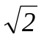 U _{n}, U _{m} and U _{n} – maximum and nominal phase stresses; Sh ₀ – initial phase of the switching on of stress; i _{su}, i _{sv and} i _{ru}, i _{rv} – currents in the stator winding and the given currents in the winding r about torus.
If rotor revolves with the variable angular velocity, then its motion op syvayetsya by the equation
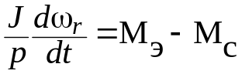, (3.4)
where J – total moment of the inertia of rotor and load mekhani z mA; p – the number of pole pairs; M _{C} – Moment of resistance; M ₃ – electromagnetic m against ment
M ₃ = (m / 2) pm (i _{su} i _{rv} –i _{sv} i _{ru}), (3.5)
where m – the number of phases AD.
For constructing the model are most convenient the equations, in which the desired variables are the fluxs linkage. In this case the model requires the minimum number of decisive blocks and is steady. In order to exclude currents, it is expressed them through the fluxs linkage, using s against the relations
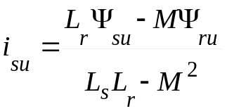 and 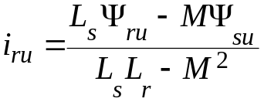;
(3.6)
and 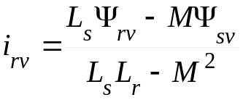.
Systems of equations (3.1 – 3.4) are valid also for the coordinates in the axes α,β and d.ts. During the record (3.1 – 3.6) in other coordinate axes it is necessary to replace indices u.v respectively on α,β or d.ts. Equation of relation, for example, between the currents in the axes α,β and u.v takes form i_{α}= i _{u} cos (ω₁ t) –i _{v} sin (ω₁ t) and i_{β}= i _{u} sin (ω₁ t) + i _{v} cos (ω₁ t).
System DU, converted to the form convenient for the simulation AD in the coordinates of the axes α,β (ω_{k} = 0), on the basis (3.1 – 3.6)
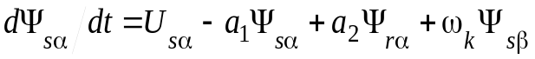;
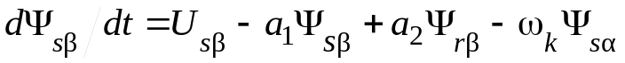;
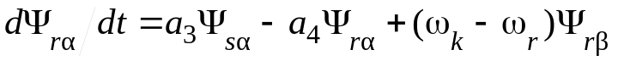; (3.7)
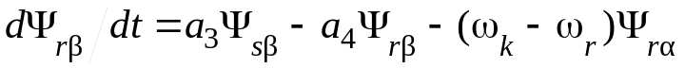;
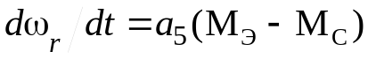;
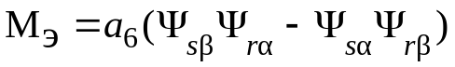,
where the coefficients with the variables are equal: 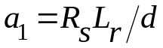; 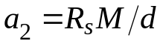; 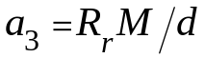; 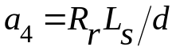; 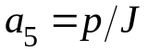; 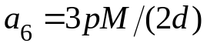; 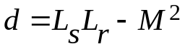.
Harmonic functions in (3.7), the determining stresses is drunk and niya, U _{s} are equal_{α}= U _{m} cos(ω₁ t) and U _{sβ} = U _{m} sin(ω₁ t).
In the converted system the currents explicitly are absent; however, if necessary they can be determined from (3.6). Armature currents and rotor in the axes α,β on the basis (3.6) it is possible to write down with the aid of koeffitsiye n of tov with the variables as
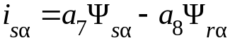, 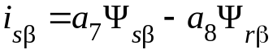
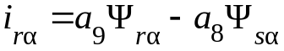 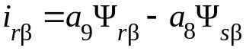, (3.8)
where 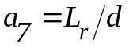 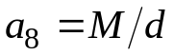 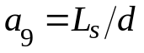.
A maximally possible (impact) value of phase armature current during the launching in the regime KZ (at the initial moment of the launching, when rotor is fixed, i.e. ω_{r} = 0, and it is possible to disregard the magnetizing current) according to the diagram of zameshch e of niya AD
I _{S K in d} = K _{in d} I _{S K m} = K _{ud} U _{m} / Z _{K}, (3.9) where K _{in d} = 1 + e^{–πR} _{to} ^{/ X} _{to} = 1 + e^{–π/ (ω}₁^{τ}_{k}⁾ – current impact coefficient; X _{K} =ω₁ (L_{σs} + L_{σr}), Ohm, R _{K} = R _{S} + R _{r}, Ohm and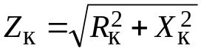, Ohm – respectively inductive, active and complete reactances OF KZ; τ_{To} = L _{K} / R _{K}, with L _{K} = X _{K} /ω₁, H – time constant and inductance KZ; U _{m} = U _{n}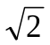, B and U _{n} – maximum and nominal phase stresses, V; I _{S K m} – steady maximum 6current KZ, A.
Coefficient of the multiplicity of transient current to the amplitude of current in the steady-state regime
K _{i} = i _{S K in d} / (I _{1H}) = i _{S K in d} / I _{1 m}, (3.10)
where I _{1n} and I _{1 m} – nominal and amplitude armature currents, A (with voltage e of NII є - Scientific Research Institute» U _{n}).
Impact internal torque during the launching AD, N?m
M _{ek in d} ~ m K _{in d} I ² _{S K m} R _{r} (1 + 1 / cosϕ_{K}) /ω₁ = K _{in d M} M _{H}, (3.11)
where cosϕ_{K} = R _{K} / Z _{K}; M _{N} = pp. _{2n} / (ω₁ (1 –s _{n})) – nominal moment, N?m; P _{2n} – useful nominal power, W; K _{in d M} – the coefficient of impact moment. Starting time AD without n and of loading, s
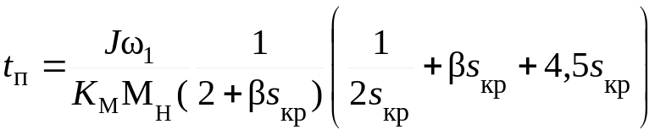, (3.12)
where K _{M} = M _{m} / M _{n} – the multiplicity of maximum moment; M _{m} = M _{3 m} – maximum internal torque on the quasi-static characteristic with kr and the ticheskom slip s = s _{kr}; 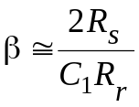; 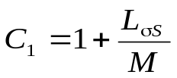.
In the regime KZ at the end of transient process are determined the coefficients of the multiplicity of the starting current
K _{OF I} = I _{1 P} / I _{1H} = I _{S K m} / I _{1 M} (3.13)
and the moment
K _{P} = M _{P} / M _{H}, (3.14)
where I _{yP} = I _{S K m} / 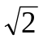 and M _{P} – being steady in the quasi-static characteristic with s = 1 value of starting armature current and starting mome n that.
In AD of average power the impact values of currents and moments practically do not depend on moment of resistance. With an increase in the moment n and loading grows only the starting time. The strengths of transient currents and moments in the regime KZ depend on inductive and effective resistance, and the greater they are, the less impact current and moment. Last opred e lyaetsya by the currents of transient regime and because of this differs from n and of chal'nogo starting torque of that found from the static the nature and stike.
With the rise of load the peak values of moments and currents depend on the value of a change in the moment of resistance, but they do not exceed znach e of niy of impact to mome n of tov and currents during the launching.

3.1. Composition of structural the block – of the diagram
Block diagram of model AD in the coordinates α,β (u, v) (Fig. 3.1) it is comprised according to system DU (3.7) and (3.8). It contains 5 blocks of integration (Integrator (In)), 9 units of summing up (Sum), of 6 blocks of multiplication (Product (Prod)), 14 blocks of intensification (Gain (G)), 2 blocks of constants (Constant (const)). The blocks also enter into the schematic of model: sine wave oscillators (Sine wave (Sw)), the generator of stepped signal (Step) and the recording units of the results of calculation – oscillographs (Scope) and the graph plotter (XY Graf) with two entrances, which ensures graphing of dependence one value (one entrance) being simulated from another (second entrance). Multiplexer (Mux) serves for the association of two input signals into one output, which makes it possible to reproduce on the oscilloscope face (Scope) of two fun to tsii
First two equations (3.7) contain the harmonic functions of the voltage of supply U _{Sα}= U _{m} cos[(ω₁ –ω_{k}) t +Ψ₀] and U _{Sβ} = U _{m} sin[(ω₁ - ω_{k}) t +Ψ₀], which for Ψ_{with 0} = 0 are formed with the aid of two generators of sine and dal'nykh oscillations (Sw 1 and Sw 2). For the simulation of stress U _{Sα}it is necessary to assign the following parameters of block Sw 1: the amplitude of stress U _{m}, the frequency of the network ω₁ = 2 r f the phase of the stress Ψ₀ = 0. For the simulation of stress U _{Sβ}it is necessary to assign following p and of rametry of block Sw 2: the amplitude of stress U _{m}, the frequency of the network ω₁ = 2 r f phase voltage e of niya Ψ₀ = r/2.
For obtaining the fluxs linkage Sh _{Sb} and Sh _{sv}, according to the first two equations of system (3.7) are used two groups of the blocks, each of which consists of adders, amplifiers and integrat against the ditch.
The third and fourth equations of system (3.7) are realized so with the aid of the group of the blocks: amplifiers G 5 –G 8 , adders Sum 3 –Sum 4 integrators In 3 –In 4, at the output of the latter are formed fluxs linkage to sootvetstve n but Sh _{Sb} and Sh _{sv}.
For the simulation of the frequency of the rotation of the rotor ω_{r} on the basis of the fifth equation of system (3.7), in the block diagram are used the blocks: Step for the formation of moment M _{s}, which reproduces load conditions AD, adder Sum 7, entrance of which enter the moments M ₃ and M _{s,} amplifier G 9 and integrator In 5 . Oscillographs Scope 1 and Scope 2 are used for the observation on the screen of temporary dependences Me, ms and 5 _{r}.
For obtaining internal torque, according to the sixth equation, 2 blocks of the multiplication are used: Prod 5 and Prod 6, the forming works respectively (Sh _{Sb} and Sh _{r in}.) (Sh _{sv} and Sh _{rb}). These works enter the entrances of adder Sum 6, and then the sum of these prod. e of deniy is introduced into amplifier G 10, at the output of this amplifier of formir in yetsya M ₃.
For determining the armature currents i _{sα}(i _{su}) and rotor i _{rα}(i _{ru}) along the axis α (u) block diagram is augmented by amplifiers G 11- G 14, and also by adders Sum 8, Sum 9, which realize system of equations (3.8). Oscillographs Scope 3 and Scope 3 are used for registering these currents.
During the solution of equations (3.7) and (3.8) in the axes α,β, to the blocks of constants const 1 and const 2existing in the structural block diagram are assigned the values p and of rametrov k =ω_{k} = 0. In this case at the output of adder Sum of 5 poluch and the quarter deck –ω_{r} . The blocks of multiplication Prod 1 –Prod 4 serve for obtaining on their outputs so on about exterminations Sh _{Sb} ·shch _{k}, Sh _{sv} ·shch _{k}, Sh _{rb} · (ω_{k}–ω_{r}) and Sh _{rv} · (ω_{k} + ω_{r})
For the blocks: generators Sw 1 and Sw 2 (sinusoidal oscillations) and Step (stepped signal) are assigned the parameters, indicated into tabl.e.ya.
If process in axes u , v is simulated , then to the parameters of blocks const 1 and const 2 are established values to =ω_{k} = 2πf ₁; in this case at add output and torus Sum 5 is formed the difference (ω_{k}–ω_{r}). In addition to this, it is necessary to establish for the sine wave oscillators Sw 1 and Sw 2 values of the frequency ω= ω₁ –ω_{k} = 0.

3.2. Calculation of the coefficients of the decisive blocks
In the work it is investigated BY AD of the type Of aya2-', which has following technical specifications, which are initial data for the simulation per e of the khodnogo process: U _{N} = of 220/380 v, P _{2H} = of 1,7 k.Bt; I _{1H} = 7,5/4,3 A; M _{H} = of 17,46 N?m; cosϕ_{N} = 0,75; η_{N} = 79,5; S _{H} = 0,07; s _{kr} = 0.2; K _{I} = 4,5; K _{P} = 1,4; K _{M} = 1,8; 2r='; f = of 50 Hz; m = 3; J = of 0,0148 kG?m ²; the parameters of circuit of zameshch e of niya: R _{s} = 3, by.shch"Om; R _{r} = 3,8 Ohm; X _{M} = 82,52 Ohm; X_{σs} = 4,99 Ohm; X_{σr} = 8,28 Ohm.
Calculations is carried out for M _{with} = 0, M _{with} = M _{N} and M _{from} ~y,shch M _{N}, ω₁ = 314 1/s, ω_{to} = 0 and t = t _{p} (3.12).
On the basis of technical specifications are calculated first the parameters, indicated in table 3.1, where U _{N} = of 220V and I _{1H} = ya,Ea – the phase values of voltage and current, and then – according to (3.7) and (3.8) coefficients r e of the shayushchikh blocks and ₁ –and ₉ (see Table 3.2).
That b of face 3.1
U _{m} = U _{N}  In | I _{1 m} = I _{1H}  A | ω₁ = 2r f 1/.c | M, H  (3.3) | L_{σs,}  H  (3.3) | L _{s},  H  (3.3) | L_{σr},  H  (3.3) | L _{r},  H  (3.3) | d,  H ²  (3.7)

That b of face 3.2
and ₁ (3.7) | and ₂ (3.7) | and ₃ (3.7) | and ₄ (3.7) | and ₅ (3.7) | and ₆ (3.7) | and ₇ (3.8) | and ₈ (3.8) | and ₉ (3.8)

3.3. The operating instructions
1.With the study of launching all blocks of integration have nul e to vye n and chal'nye conditions (established on silence).
2. The launch procedure of engine is accompanied by the significant current surges and internal torque. Transient currents and moments are observed during the first half-period. At the end of launch procedure without the load (if we consider THE XX as ideal) internal torque becomes equal to zero, and the frequency of rotor reaches synchronous. The observance of these conditions testifies about the correctness of model, created on personal comp. 6 to yutere.

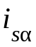 | Fig. 3.1
3. The coordinates of the extrema of current or moment first determine with the aid of soo t of the vetstvuyushchikh knobs of block Scope (Zoom, Zoom X - axis or Zoom Y - axis) and then, after harvesting the left key for mouse with the aid of the dynamic framework or the section they indicate the region of the graph of dependences 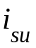 (), M ₃ for a magnification in the image. In the coordinates α,β current in the phase A of the stator of three-phase machine is equal to prompt current in the phase b of two-phase machine. Starting time t _{p}, for which the rotor from the fixed state will reach the steady frequency of rotation, is determined according to graph we depend about sti Me (t).
4. With the study of launching induction motor with the moment of load M _{C,} the latter is assigned with the aid of the parameters of block Step: In i tial value = 0, Final value = M _{C} and Step time = 0.
5. The rise of load (NN) also is achieved with the aid of BL about kA step. Parameters of block Step: Initial value = 0, Final value = M _{C} and Step time = t, where tentatively it is possible to accept time t = 2tp. and launching of engine, NN is accompanied by the current surges and internal torque. During the simulation of armature current i _{S} and moment M ₃, are determined their peak zn and of cheniya. The time of transient regime is counted off from the moment of the rise of load to the moment of reaching by the rotor of the nominal frequency of rotation.
6. For finding maximum internal torque M _{3 m} one should carry out the rise of moment M _{s}, changing parameter Final value = M _{C} of block Step, first with the steep pitch of its increase, and then, at the approach up to the maximum moment with the smaller step. Are determined two moments, increases differing to the value of the smallest step. The engine works stably with the smaller value of moment, while with larger – the frequency of rotation decreases to zero. First, smaller zn and cheniye M _{s} determines value M _{3 m}. Overload capacity AD is defined by the ratio of maximum moment to nominal'n about mu as K _{M} = M _{3 m} / M _{H.}
7. In the regime KZ the rotor of engine is fixed. In this regime 5 _{r} = 0 the parameter of amplifier G 9 is reduced to zero. At the end transitional protse with SA are determined the potential values of armature current I _{yP} also of moment M _{P}, by which are calculated the coefficients of the multiplicity of starting current K _{I} on (3.13) and the multiplicity m on menta K _{P} on (3.14).
8. The fulfillment of laboratory work requires the comparison of the parameters, obtained as a result of the simulation (it is sweated), with their calculation, and catalog data. The calculated parameters preliminarily are determined according to table 3.3.. Possible differences in comparative data will be explained by the fact that in the present work is simulated the idealized machine, in which are not considered the losses in the steel magnetic circuit, mechanical losses and highest of garmon and Ci.

Table 3.3
, rel.un..  (3.12) | With ₁, rel.un..  (3.12) | T _{P}, s  (3.12) | R _{K}, Ohm  (3.9) | X _{K}, Ohm  (3.9) | L _{K}, H  (3.9) | f _{K}, s  (3.9) | Z _{K}, Ohm  (3.9) | Cosq _{K}, rel.un..  (3.11)

The values of the parameters of functional blocks for the diagram (ris.e.y)v the axes of b,v are given in table 3.4.
Table 3.4
Block | Vapor and the meter | Block | Vapor and the meter | Block | Vapor and the meter
G 1 | and ₁ | G 6 | and ₃ | G 11 | and ₇
G2 | and ₂ | G 7 | and ₃ | G 12 | and ₈
G 3 | and ₂ | G 8 | and ₄ | G 13 | and ₈
G 4 | and ₁ | G 9 | and ₅ | G 14 | and ₉
G5 | and ₄ | G 10 | and ₆ | Const1  and  Co n st2 | ω_{k}
Sw1 | Um = 311  In  Ψ₀ = 0  ω₁ = 314,  1/s | Sw2 | Um = 3 11, V  Ψ₀ = 1,57  ω₁ = 314, 1/c | Step | Step time - t  Initial value - The mi  Final value - Mf

3.4. program and the operation procedure
to y.Podgotovit' table 3.1 – 3.9 with the introduced results of the calculations by those indicated in them of the parameters for asynchronous eng. being investigated and calving.
2. to draw equivalent circuit AD and structural block diagram (Fig. 3.1) with substituted computed values of the coefficients of the decisive blocks.
3. to compose block diagram (Fig. 3.1) with the aid of SIMULINK.
, rel.un..  (3.12) | With ₁, rel.un..  (3.12) | T _{P}, s  (3.12) | R _{K}, Ohm  (3.9) | X _{K}, Ohm  (3.9) | L _{K}, H  (3.9) | f _{K}, s  (3.9) | Z _{K}, Ohm  (3.9) | Cosq _{K}, rel.un..  (3.11)
ya.Dlya of the simulation of the regime of launching in the axes (b, c), i.e., with ω_{To} = 0, the values of the parameters of the decisive blocks to assign, using tabl.e.2 and table 3.4.
5. to assign for the regime of launching AD without the load (KHKH) the parameters of block Step: Initial value = 0, Final value = 0 and Step time = 0.
6. For the simulation of process to assign in menu Simulation the interval of simulation (Simulation Time), after indicating the initial (Start time) and final (Stop time) values of the time: Start time = 0, Stop time = 0,5; as the method of integration to select method ode 45 - Runge method by Kutta 4 and 5 porya d of kov.
7. to investigate the regime of launching AD without the load (KHKH). To carry out the simulation of currents i _{sα}= f (t), i _{rα}= f (t), moment M ₃ = f (t) and the frequency ω_{r} = f (t). To determine according to the data of the simulation of the value: transient armature current i _{Sαin d}; the impact moment M _{of eud}; the maximum frequency ω_{r m} and in establish into shemsya the process of the value: the maximum current I _{Sαm}; the frequency ω_{r}; starting time t _{P}, and also coefficients K _{ud} = i _{Sαin d} / I _{Sαm} and K _{in d M} = M _{of eud} / M _{N}. Data of simulation to enter in table 3.5 and 3.6.

That b of face 3.5
R e the press | Axes | I _{Sαin d}, A  (it is sweated.) | I _{Sαm}, A  (m about the matters.) | I _{yN}, A  (m about the matters.) | K _{in d}, rel.un..  (mho d it ate.)
KHKH | b,v |  |  | ___
NR | b,v

Table 3.6
R e the press | Axes | M _{of ъ d}, N?m (m about the matters) | K _{in d M}, (rel.un..) (it is sweated) | ω_{rm}, 1/c (m about the matters) | ω_{r}, 1/c |  | T _{P}, s  (m about the matters)
 |  |  |  |  | ω₁ (1 s) | (m about the matters)
KHKH | b, in
KHKH | u, v
NR | b, in
8. To derive on the press of drawing i _{Sα}= f (t), i _{rα}= f (t), M ₃ = f (t) and ω_{r} = f (t).
9. To carry out the simulation of transient response M ₃ = f (ω_{r}) (phase portrait) with p about by the power of block XY Graf after assigning the parameters: Xmin = - 10, Xmax = 350, Ymin = - 10, Ymax = 60.
10. To derive on the press of drawings M ₃ = f (ω_{r}).
11. To investigate the regime of launching under the load for the the nominal of rezh and mA (NR). To assign the parameters of block Step: Initial value = 0, Final value – M _{C} = M _{n} and Step time = 0. Vypo l thread is simulation i _{sα}= f (t), i _{rα}= f (t), M ₃ = f (t) and ω_{r} = f (t). To determine according to the data of the simulation of value of i _{Sαin D}, M _{3 in D}, ω_{r m} and in steady state for M ₃ = M _{N} – currents I _{Sαm} = I _{1 m}, I _{1n} = I _{1 m} /?2, the frequencyω_{r} =ω_{r n}, and also starting time t _{P}, coefficients K _{in D} = i _{SαD has} / I _{1 m} and K _{in D M} = M _{of ъ D} / M _{n}. To carry out p. 8, 9 and 10. Data of simulation to introduce in table 3.5 and 3.6.
12. To investigate the regime of the rise of load (NN). To assign the parameters of block Step: first: Initial value = 0, Final value –M _{C} = of 44.6 N?m and Step time = 0,25 s; and then Initial value = 0, Final value –M _{C} = M _{n} and Step time = t _{P} = 0,25 c. To carry out simulation and to derive on the press of drawing i _{sα}= f (t), M ₃ = f (t), ω_{r} = f (t) and M _{s} = f (t).
13. To carry out p.y2, after assigning the parameters of block Step: Initial value = 0, Final value –M _{C} and Step time = 0,25 s, where the selected moment of resistance M _{s} = M _{3 m} = M _{m} – a maximally possible moment, with which the engine still stably works. With the fulfillment of this point to vary M _{s} in limits of M _{N} < M _{s} < 44, 6 N?m. To determine according to the data of the simulation of the value of moment M _{m}, shifting it is capable against sti K _{M} = M _{m} / M _{n} and frequencies ω_{r} = ω_{r kr} for M _{s} = M _{m}. Data of simulation to introduce in table 3.7.
Table and TsA 3.7
Regime | Axes |  | M _{m,} N?m |  |  |  | ω_{r kr}, 1/s |  |  |  | K _{M}, o. e.
NN |  | b,v |  | (3.12) |  | (m about the matters) |  | ω₁ (1 –s _{kr}) |  | (m about the matters) |  | 1,8 |  | (m about the matters)
14. To investigate regime KZ, in this regime ω_{r} = 0. To assign the parameter (amplification factor) of block G 9 and ₅ = to 0. To carry out simulation and to derive on the press of drawing i _{sα}= f (t) and M ₃ = f (t). To determine according to the data of the simulation of the value: I _{S Of ku D} = I _{Sαin D}; K _{in D} = i _{S of ku D} / I _{S K m}; K _{I} = I _{S Of ku D} / I _{1 M}; M _{ek D}; K _{in D M} = M _{ek D} / M _{n} and steady given: I _{S K m} = I _{Sαm}; I _{yP} = I _{Sαm} /?2,; K _{I} = I _{S K m} / I _{1 m} = I _{yP} / I _{1n}; M _{P} = M ₃; K _{P} = M _{P} / M _{n}. Data of simulation to introduce in table 3.8 and 3.9.
That b of face 3.8
Regime | Axes | ‌‌ I _{S Of ku d} ‌, A |  | K _{in d}, rel.un.. |  | K _{i}, rel.un.. |  | M _{ek d}, N.m. |  | K _{in d M}, rel.un..
KZ | b,v | (3.9) | it is sweated | (3.9) | it is sweated | (3.10) | it is sweated | (3.11) | it is sweated | (3.11) | it is sweated

Table 3.9
Regime | Axes | ‌‌ I _{S K m} ‌, A |  | I _{yP}, A |  | K _{I}, rel.un.. |  | M _{P}, N?m |  | K _{P}, rel.un..
KZ | b,v | (3.9) | it is sweated | (3.13) | it is sweated | 4,5 | it is sweated | (3.14) | it is sweated | (1,4) | m about the matters

15. To investigate regime KHKH in axes u, v with ω_{To} =ω₁ = 314 1/c. To assign the parameter to block const 1 coefficient ω_{To} = 314 1/c, for the formation respectively Sh _{S u} and Sh _{S v}, and for to the parameter of block const 2 also the coefficient ω_{To} = 314. For the units of sine wave oscillators SW 1 and SW 2 value of the frequency ω₁ = 0. To determine according to the results of the simulation M _{Of ъ d}, K _{in D M}, ω_{r m}, ω_{r}, and t _{P}. Data of simulation vn e of sti in table 3.6.

3.5. Task to the examination
1. To become acquainted with the description of laboratory work, to study program and order of its performance.
2. To carry out 1- e and 2- e of the task p. 3.4.

3.6. Requirements for the formulation of the report
Report must contain: specifications of eng. e lya being investigated; the system DU being investigated; the calculation of the coefficients of the decisive blocks; the figure of structural block diagram; table 3.1 – 3.9 with the introduced results of calculation and simulation; the graph of the dependences of currents and moments on vr e Mesny being investigated

3.7. Questions to the protection to the laboratory work
1. In what does consist the transformation of system DU to the form, convenient for the modes e of lirovaniya on THE COMPUTER(S)?
2. Explain the composition of block diagram and the designation of its elements (Fig. 3.1).
3. What coordinate systems were used for modelirov and of niya AD?
4. how was determined starting time AD?
5. In what regime was determined the overload capacity AD?
6. How was simulated regime KZ?
7. How was simulated launching AD in the regime KHKH?
8. how it was achieved BY NN in that investigated by m o divide?
9. how was carried out regime NR in that investigated by m o divide?
10. as to carry out a reverse AD in the model being investigated?
11. To explain, why at moment of switching on AD into network M _{P} = 0, and according to the static characteristic M _{P}≠0?
12. As to pass from the simulation in the coordinate system α,β to the system of coordinates u.v?
13. In what regime were determined coefficients K _{P} and K _{I} ?
14. In what regime were determined coefficients K _{in D}, K _{in D M} and K _{i} ?
15. How to calculate impact moment M _{ek in D} ?
16. As to calculate the moments: nominal M _{n} and starting M _{P} ?
17. What function does carry out block Step in the block diagram (Fig. 3.1) and as to assign its parameters?
18. According to what graphs and as to determine critical chipping 6 zheniye s _{kr}?
19. What functions do carry out blocks Integrator in the block diagram (Fig. 3.1)?
20.V what cases for investigating the transient process in AD is convenient the coordinate system α,β, and in what system - u, v?

